Data Manipulation and Cleaning work

Account Table
- Convert the Date attribute into a yyyy-mm-dd by adding 24 in year format in Excel or SQL
- 1993 -> 2017
- 1994 -> 2018
- 1995 -> 2019
- 1996 -> 2020
- 1997 -> 2021

- Replace in frequency attribute “POPLATEK MESICNE” AS Monthly Issuance, “POPLATEKTYDNE” AS Weekly Issuance, and “POPLATEK POBRATU” AS Issuance After a Transaction in Excel or create a case statement in SQL.
- Create a Custom Column Card_Assigned and assign below :
- Silver -> Monthly issuance
- Diamond - weekly issuance
- Gold - Issuance after a transaction
CARD Table
- Replace type attribute value “junior” as Sliver, “Classic” as Gold,
And “Gold” as Diamond by using replace in Excel or by using update in SQL.

- Convert issued attribute into yyyy-mm-dd adding 23 in year.

CLIENT Table
- Convert bith_number attribute to yyyy-mm-dd format and also create another column named sex by applying in bith_number 0 for females and 1 for males.
(=if(mod(bith_number,2)=0, “Female”, “Male”) in excel or using case statement in SQL.
For Male its in YYMMDD format and for female it is YYMM+50DD for Women

DISTRICT Table
- Change all column names and delete the attributes a12 and

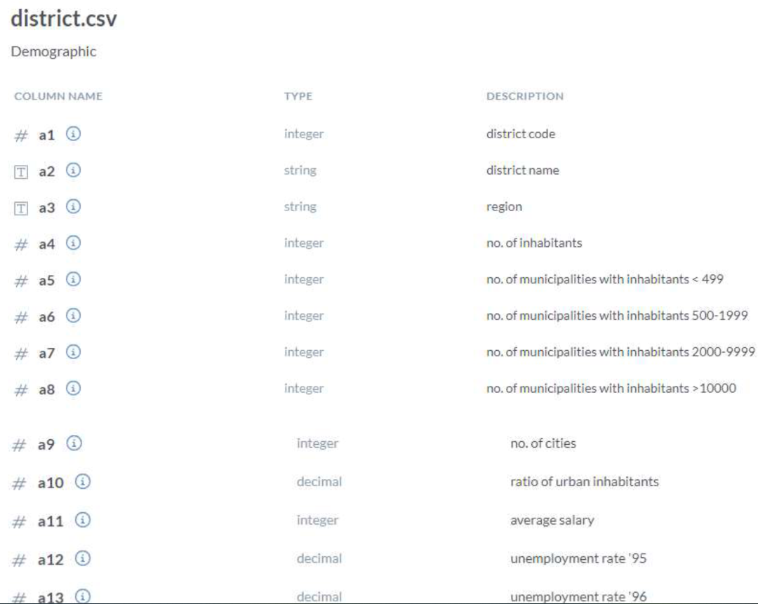
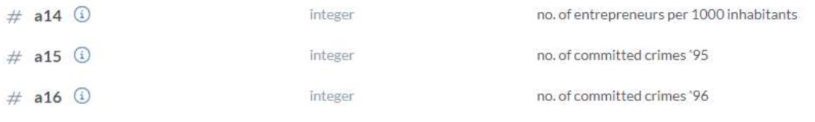

LOAN Table
- Convert the Date Attribute into yyyy-mm-dd format adding 23 in year.
- Convert Status Attribute value “A” as Contract Finished, “B” as Loan Not Paid, “C” as Running Contract, and “D” Client in debt.

In th Transactions Table do the following , whosoever count is highest sort it in descending order and change the year from 2022,2021,2020 and so on
--DATA TRANSFORMATION
/*
2021 -> 2017
2020 -> 2018
2019 -> 2019 -- NO CHANGE
2018 -> 2020
2017 -> 2021
2016 -> 2022
UPDATE TRANSACTIONS
SET BANK = 'Sky Bank' WHERE BANK IS NULL AND YEAR(DATE) = 2022;

UPDATE TRANSACTIONS
SET BANK = 'DBS Bank' WHERE BANK IS NULL AND YEAR(DATE) = 2021;

UPDATE TRANSACTIONS
SET BANK = 'Northern Bank' WHERE BANK IS NULL AND YEAR(DATE) = 2019;

UPDATE TRANSACTIONS
SET BANK = 'Southern Bank' WHERE BANK IS NULL AND YEAR(DATE) = 2018;

